# LT Spice Simulations – 10/05/2024

## LT Spice Circuit

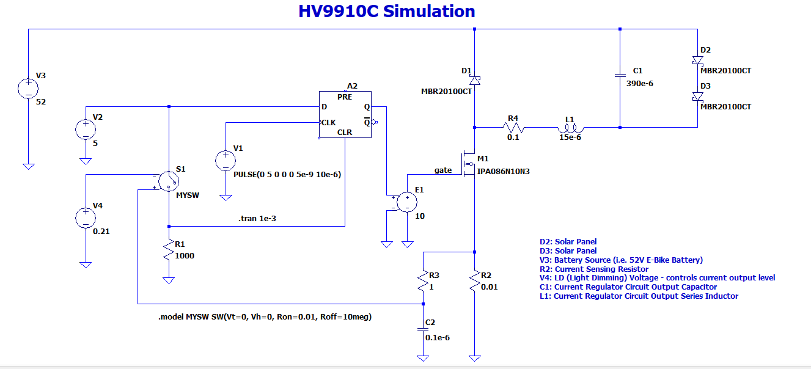

## Key Values

D2: Solar Panel

D3: Solar Panel

V3: Battery Source (i.e. 52V E-Bike Battery)

R2: Current Sensing Resistor

V4: LD (Light Dimming) Voltage - controls current output level

C1: Current Regulator Circuit Output Capacitor

L1: Current Regulator Circuit Output Series Inductor

## 10 A Simulation Results

Simulation Values:

L1 = 380 uH

C1 = 390 uF

R2 = 0.025 Ω

V4 = 0.25 V

Results – current through D2 simulated Solar Panel:

IMAX(D2) = 10.002 A

IMIN(D2) = 9.990 A

IAVG(D2) = 9.996 A

IMAXDEV(D2) = 0.006 A

IDEV(D2) = IAVG(D2) / IMAXDEV(D2) x 100 = 9.996 / 0.006 x 100 = 0.06 %

## 20 A Simulation Results

Simulation Values:

L1 = 15 uH

C1 = 390 uF

R2 = 0.01 Ω

V4 = 0.21 V

IMAX(D2) = 20.15

IMIN(D2) = 19.65

IAVG(D2) = 19.90

IMAXDEV(D2) = 0.25 A

IDEV(D2) = IMAXDEV(D2) / IAVG(D2) x 100 = 0.25 / 19.90 x 100 = 1.26 %